Construction and tests of a fine granularity lead-scintillating fibers calorimeter
P Branchini¹, F Ceradini², G Corradi³, B Di Micco¹ and A Passeri^{1,}
¹ INFN Sezione Roma Tre, via della Vasca Navale 84, 00146 Roma, Italy
² Università Roma Tre, via della Vasca Navale 84, 00146 Roma, Italy
³ INFN Laboratori Nazionali di Frascati, via E Fermi 40, 00044 Frascati, Italy.

E-mail: antonio.passeri@roma3.infn.it

Abstract. We report the construction and the tests of a small prototype of the lead-scintillating fiber calorimeter of the KLOE experiment, instrumented with multianode photomultipliers to obtain a 16 times finer readout granularity. The prototype is 15 cm wide, 15 radiation lengths deep and is made of 200 layers of fibers 50 cm long. On one side it is read out with an array of 3×5 multianode photomultipliers Hamamatsu type R8900-M16, each segmented with 4×4 anodes, the read out granularity being 240 pixels of 11 × 11 mm² corresponding to about 64 scintillating fibers each. These are interfaced to the 6 × 6 mm² pixeled photocathode with truncated pyramid light guides made of Bicron BC-800 plastic to partially transmit the UV light. Each photomultiplier provides also an OR of the 16 last dynodes that is used for trigger. The response of the individual anodes, their relative gain and cross-talk has been measured with the light (440 nm) of a laser illuminating only few fibers on the side opposite to the read-out. We finally present the first results of the calorimeter response to cosmic rays in auto-trigger mode.
- Introduction
The lead-scintillating fibers calorimeter of the KLOE experiment at the DAFNE ϕ-factory has taken data for many years and has proven to provide excellent performances as tracking calorimeter and time of flight detector at low energy [1,2]. It is made by stacks of about 200 grooved 0.5 mm thick lead foils alternated with layers of cladded 1 mm diameter scintillating fibers. The fibers are arranged in a periodic equilateral triangle array whose side is 1.35 mm, as shown in fig. 1. The final result is an almost homogeneous compound of lead:fibers:glue with relative volume fractions 42:48:10. The average density is ~5 g/cm³ and the radiation length ~1.5 cm. The scintillating fibers have a fast scintillating decay time of ~2.2 ns and the light attenuation length along them is around 4 m. Due to the very high scintillator content such detector is extremely well suited both for energy and time measurements. The measured energy resolution for photons in KLOE is 5.7%/√E(GeV) with a negligible constant term, while the intrinsic time resolution of the calorimeter is 54 ps/√E(GeV) + 50ps , the constant term being due to residual miscalibrations between cells.
In the KLOE calorimeter the spatial reconstruction of the energy depositions is obtained, for the coordinate along the fiber length, by measuring the arrival time difference of the scintillating light at both ends of the fibers, which provides a resolution of ~1 cm when the energy is released at a distance of 2 m from the photomultiplier. The reconstruction precision transverse to the fibers is determined by
the size of the light readout cells, which are squares of 4.4 x 4.4 cm² at both sides of the calorimeter.

Figure 1. Lead- scintillating fibers structure in the KLOE calorimeter.

This segmentation yields a resolution of ~1.3 cm (4.4/√12) for isolated showers, which matches the average shower size. However, such coarse granularity does not allow to disentangle two nearby energy deposits, which in KLOE may occur quite frequently and have a high probability to be merged if the distance between their centroids is less than 20 cm. This limitation is particularly nasty in all physics analyses in which the photon counting is crucial to separate signal and background. Moreover, the coarse granularity does not allow to track the details of the energy deposition development, which are essential to identify the different kind of particles entering the calorimeter.
A detailed FLUKA simulation of one KLOE calorimeter module [3] showed that, increasing the readout granularity by a factor of 16 (i.e. making 1.1 x 1.1 cm² elementary readout cells), couples of particles impinging into the calorimeter with a separation down to few centimeters can be easily disentangled, and that the energy deposition shape for electrons and muons can be reconstructed to a level that allows efficient particle identification on an event by event basis.
Here we present the practical implementation of this concept on a small prototype of the KLOE calorimeter, having the standard thickness of about 15 radiation lengths, length of 50 cm and width of 13.5 cm. On one side a matrix of 3 x 5 standard KLOE light guides and PMs had been already installed. We designed a completely new readout structure for the other side, where the 3 x 5 matrix of KLOE cells is matched by 15 macro-cells, each segmented into 16 cells 11 x 11 mm wide and read out by a multi-anode photomultiplier with 16 anodes.

- Multi-anode photomultipliers characterization
We have chosen the Hamamatsu R8900 M16 multi-anode photomultiplier [4], the latest development of conventional multi-anode technology based on weak electrostatic focusing and implementing bi-alkali photo-cathodes. This device has a sensitive surface which is 83% of its physical area (25.7 x 25.7 mm²) and provides a compact readout solution for our detector. The photocathode is segmented into a 4 x 4 matrix where each cell has a nominal active surface of 6.0 x 6.0 mm² and a dead zone 0.3 mm wide is present between any two adjacent cells. Beside the 16 cells output signals, the device provides also in output the sum of its 16 last dynodes, which is very useful for triggering purposes. Finally, this device exists also in an improved quantum efficiency version: we used three of such PMs for the readout of the first plane of the prototype.
It is well known that multi-anode PMs suffer by wide response non-uniformity between different cells, which have to be accounted for in data reconstruction. We studied such effect in laboratory by means of the Hamamatsu Laser pulser PLP-10 at 440 nm, which provides light pulses of 100 ps duration. We illuminated each single cell and we studied its charge response as a function of the supply high voltage. The response at a generic high voltage V is normalized to the response at V=500 V. In each cell the behaviour is well described by an exponential function, with similar slopes

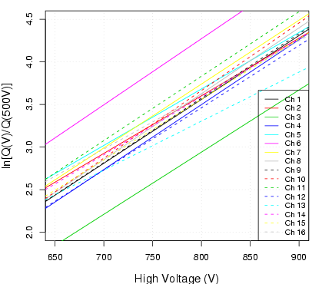 |  | 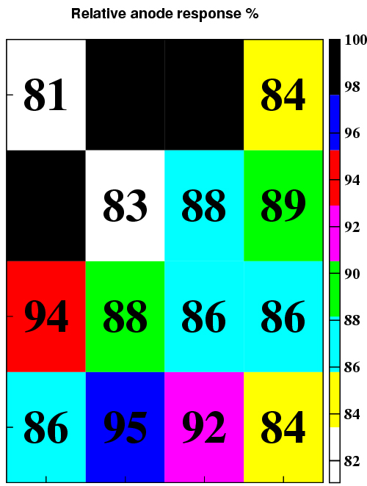
Figure 2. Charge response as a function of high voltage for the 16 anodes of a single R8900 M16. Only the fits are shown to save space. |  | Figure 3. Charge response variation at HV=800 V in a typical R8900.

but with wide offset variations, as it is shown in fig.2 for an individual PM. Figure 3 shows the charge response level in the cells of a single R8900 at a working point of 800 V. Typical response variations are in the range of 20% , which in some individual cell may occasionally reach 30-35%.
A second important issue for multi-anode PMs is the cross talk between different cells due to the internal structure of the device. We studied also this effect by illuminating a single cell and measuring the charge response of all the others. In this way we build a cross talk matrix for each R8900, of which an example is shown in fig.4. The cross talk level is generally around few per cent, apart from single cases in which only the cell adjacent to the illuminated one may reach 20-30%.

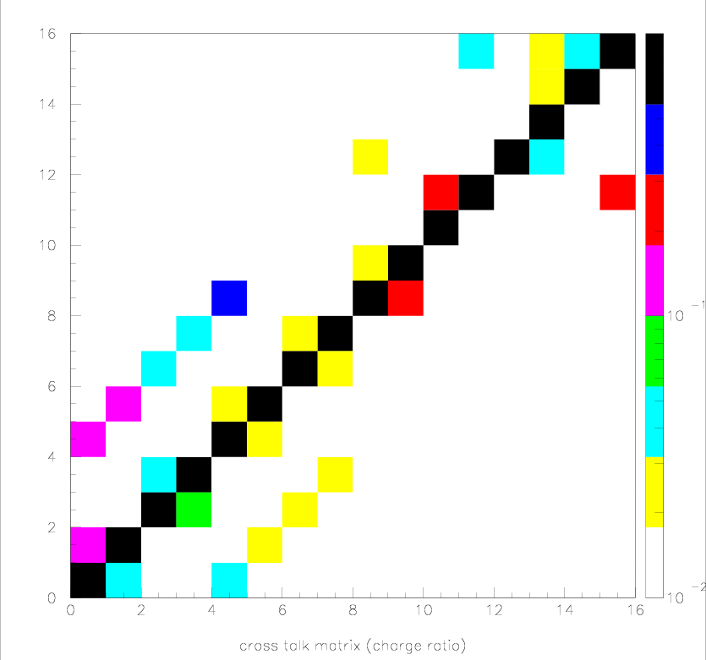
Figure 4. Cross talk matrix for a single R8900 at 800 V. Illuminated cell on the x axis, responding cell on the y axis.
- Light guides and mechanics
A 11 x 11 mm² readout cell corresponds to about 64 scintillating fibers. To collect the light emitted by such fibers and to concentrate it into one 6.0 x 6.0 mm² photocathode cell of the R8900-M16 a special set of light guides has been designed and realized. An overall truncated pyramid structure maps the 16 elementary cells corresponding to one KLOE cell into one multi-anode PM. Such structure is actually segmented into 16 individual light guides which map each single readout cell into a 5.7 x 5.7 mm² square in the centre of one multi-anode cell (we prefer not to use the edges of the photocathode cells which are usually less efficient). Individual guides have three slightly different shapes depending whether they are at the corners, at the centre or at the sides of the macro-cell. A length of 6 cm is enough to keep all the guide faces well below the minimum reflection angle. The UV transparent BC800 plastics from Bicron has been used for all the guides. An aluminium grid (anodized in black) keeps the guides in place on the cathode side. Individual guides are only separated by a thiny slice of air (the plastic-air contact surface being the most advantageous for light reflection) and they touch each other only on the calorimeter surface. A picture showing details of the light guides structure is presented in figure 5.

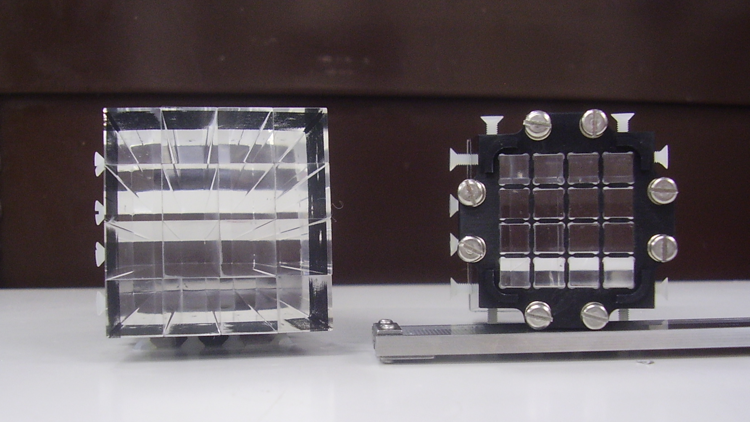
Figure 5. View of two blocks of 16 light guides, one seen from the side to be glued to the calorimeter, the other seen from the side to be put in optical contact with the R8900.

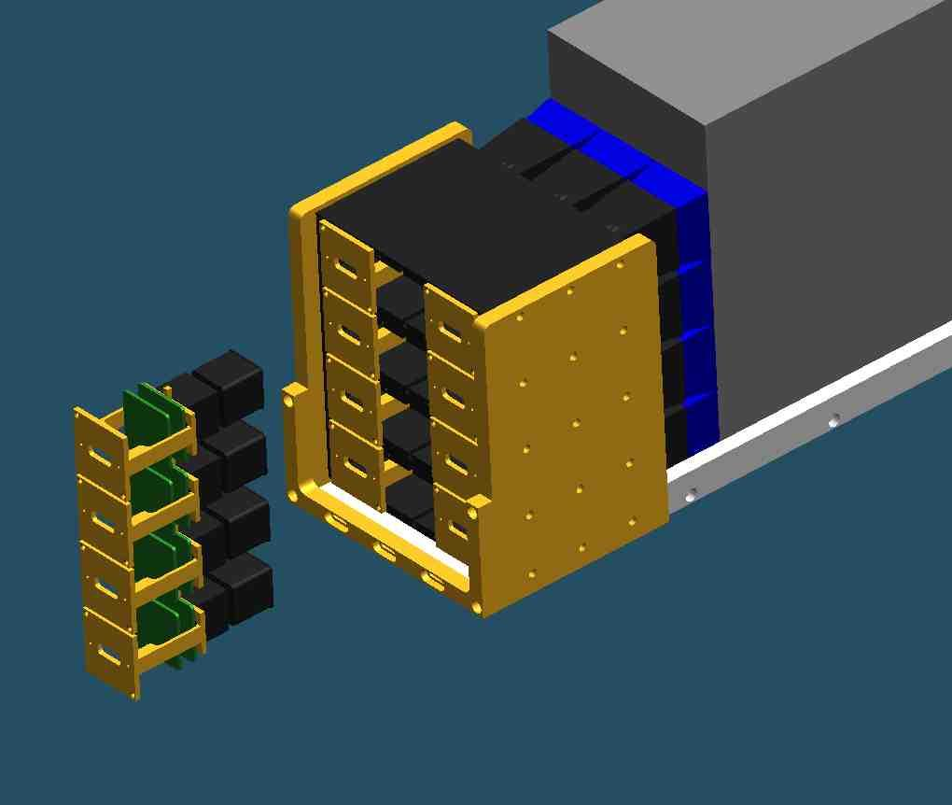
calorimeter
PM case
Multianode
socket
electronics
Segmented light guides
Figure 6. Mechanical sketch of the readout support structure (here only 4 PM rows are showed, instead of the final 5)
A mechanical structure, sketched in fig.6, has also been designed to support the PMs and their electronics and to allow easy insertion and extraction of individual PMs.
- Electronics and data acquisition

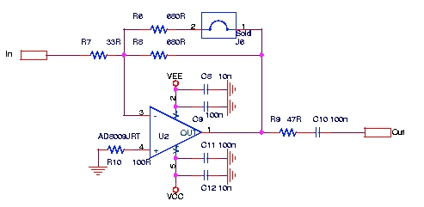
Figure 7. Inverting preamplifier stage for a single multi-anode channel.

- Optical cross talk determination

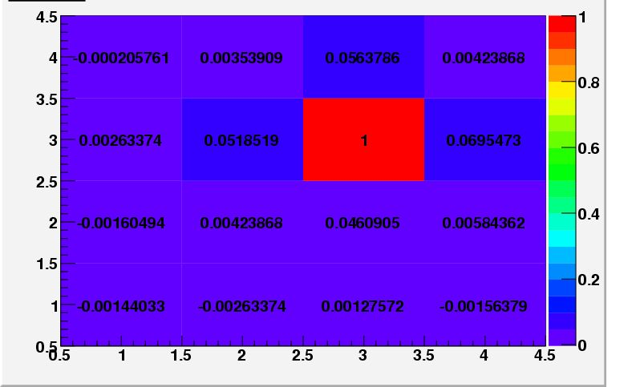 |  | 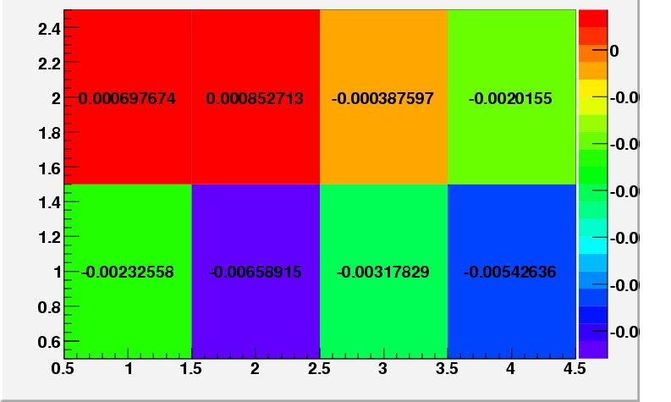
Figure 8. Typical response pattern when a single cell is illuminated in an individual multi-anode PM. |  | Figure 9. Response pattern on half multi-anode when one adjacent cell of the neighbour PM is illuminated.

- Cosmic rays test

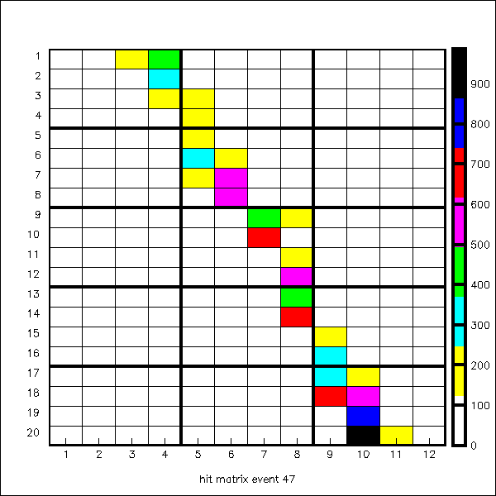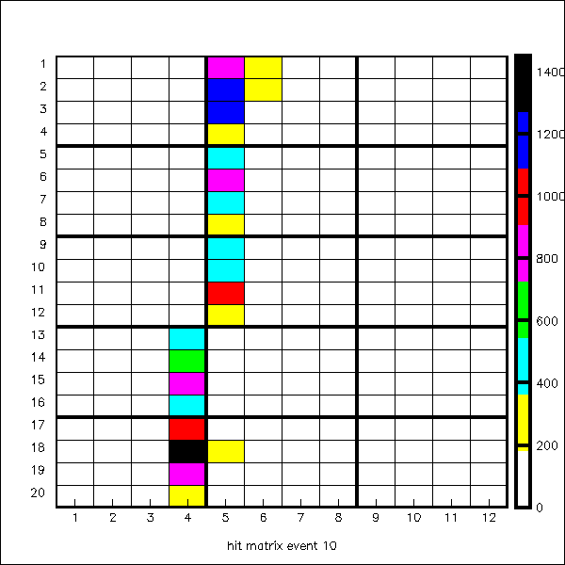
Figure 10. Typical cosmic rays event displays.

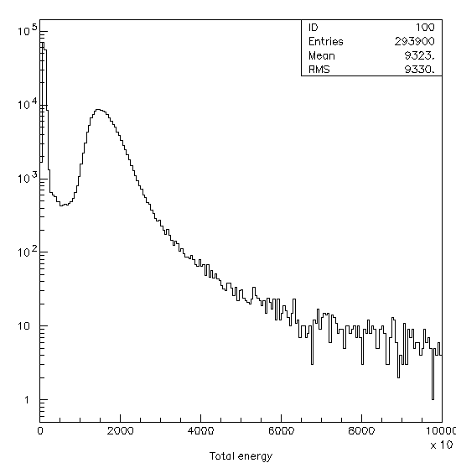 |  | 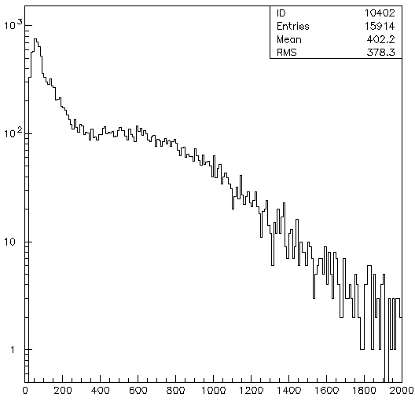
Figure 11. Offline sum of all the cells above threshold in one multi-anode PM over 50000 cosmics events. |  | Figure 12. Single cell spectrum for cosmics events.

Acknowledgments
Work partly supported by a PRIN grant from Ministero dell’Università e della Ricerca Scientifica.
We wish to thank…..
References

[1] Adinolfi M et al. 2002 The KLOE electromagnetic calorimeter Nucl. Inst. Meth. A 482 364
[2] Ambrosino A et al. 2004 Data handling, reconstruction and simulation for the KLOE experiment Nucl. Inst. Meth. A 534 403
[3] Di Micco B, Ferrari A, Passeri A and Patera V 2006 A FLUKA simulation of the KLOE calorimeter Proceedings of Siena Instrumentation Conference
[4] Kawasaki Y et al. 2006 Performance of a multi-anode photomultiplier employing a weak electrostatic focusing system (Hamamatsu R8900 series) Nucl. Inst. Meth. A 564 378
[5] Antonelli M et al. 1998 The ADCs and TDCs for the KLOE electromagnetic calorimeter Nucl. Inst. Meth. A 409 675
[6] Aloisio A et al. 2004 Data acquisition and monitoring for the KLOE detector Nucl. Inst. Meth. A 516 288

To whom any correspondence should be addressed.

